**Circuit Guide:**

Usually, circuits are not represented with pictures, but with schematics! A schematic is the most common, basic representation of a circuit where each component is represented by their own unique symbol. Lines are drawn from symbol to symbol in order to represent how the components should be connected to one another. Below are pictures of the components that are in your kit next to their associated schematic symbol.

Battery/Voltage Supply:

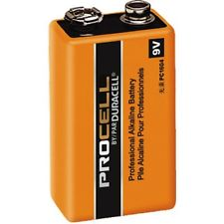 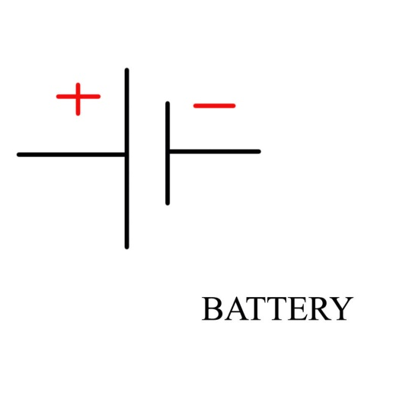

Light Emitting Diode (LED):

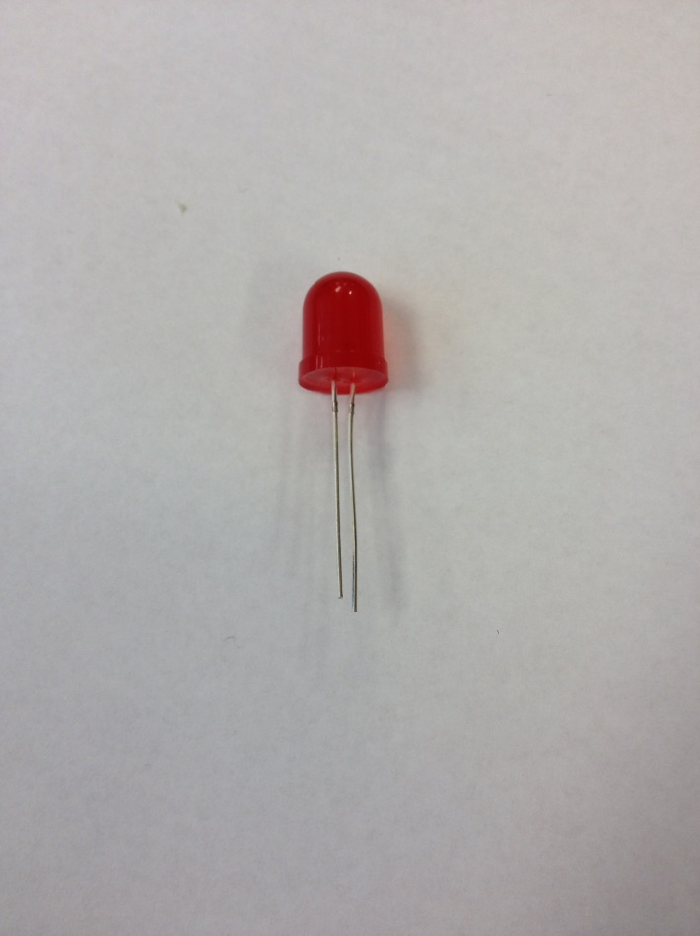 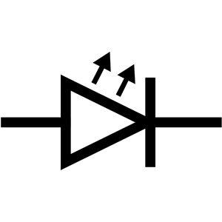

Resistor:  
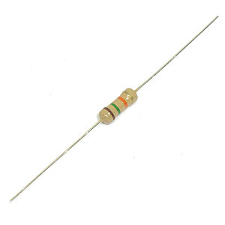 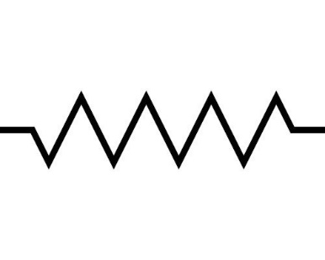

Potentiometer (Variable Resistor):

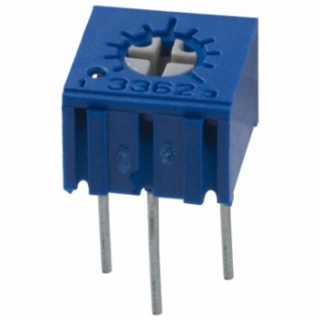 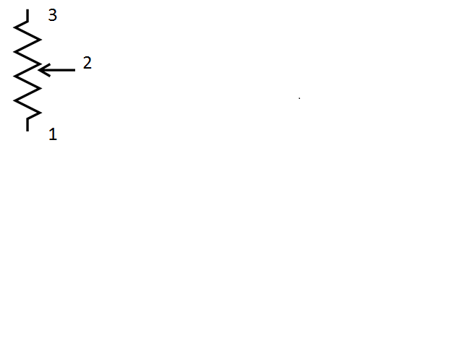

Electrolytic Capacitor:

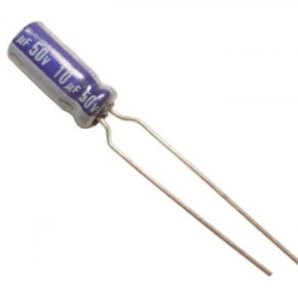 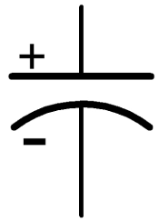

Transistor:

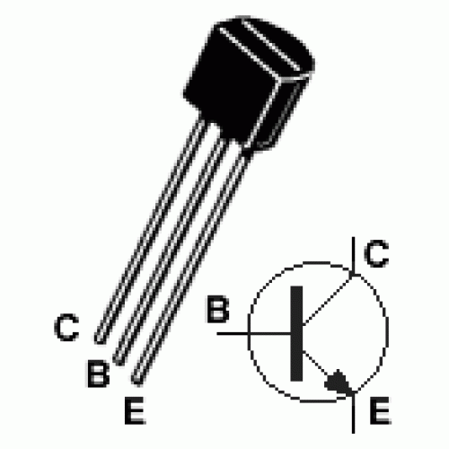

Schematics:

**Simple LED Circuit**

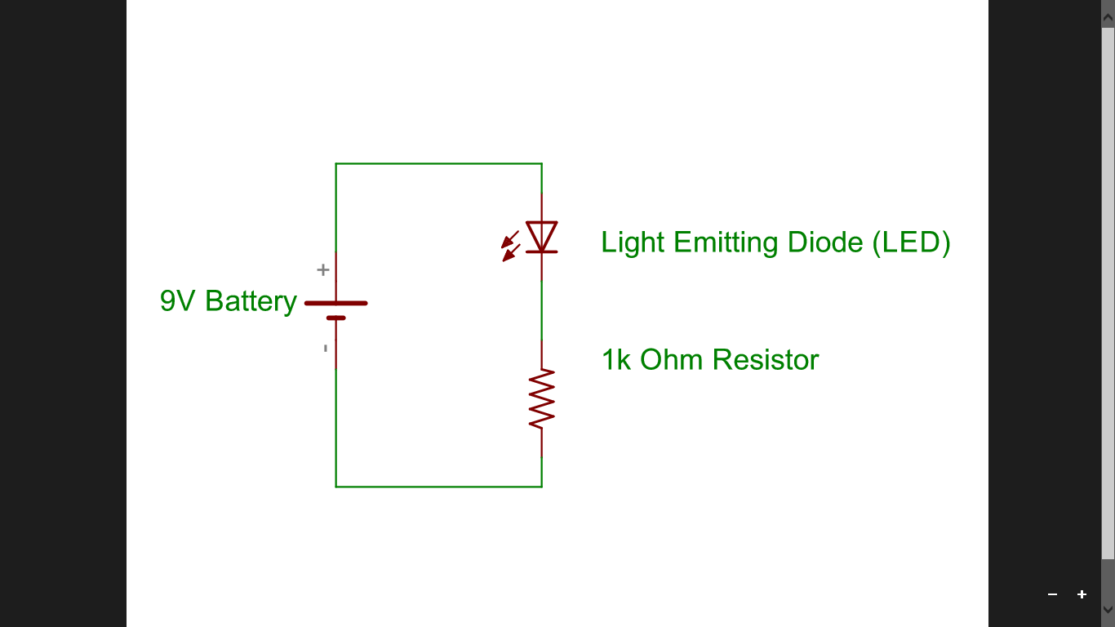

**Dimmer Circuit**

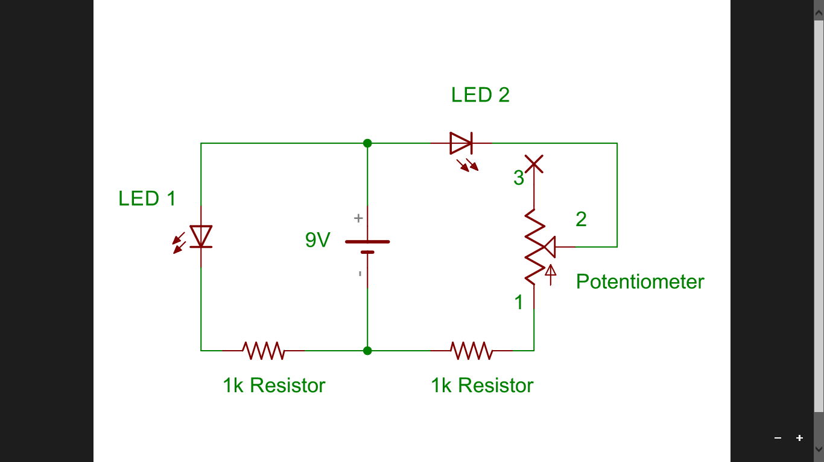

**Welcome to the Resistance Circuit**

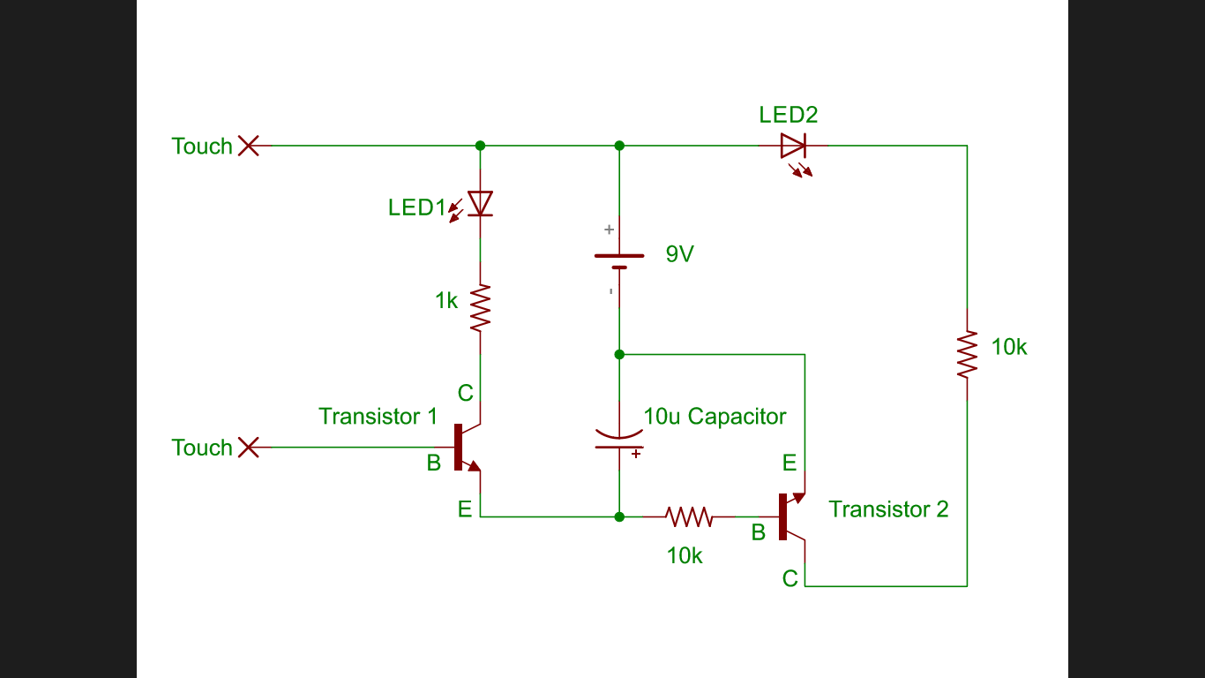

Simple LED Circuit:

First, you will want to make sure that you acquire all of the components listed below before you begin making this circuit:

1. Breadboard
2. Battery and Battery Snap
3. LED
4. 1k Resistor (brown, black, red, gold)
5. Jumper Wire

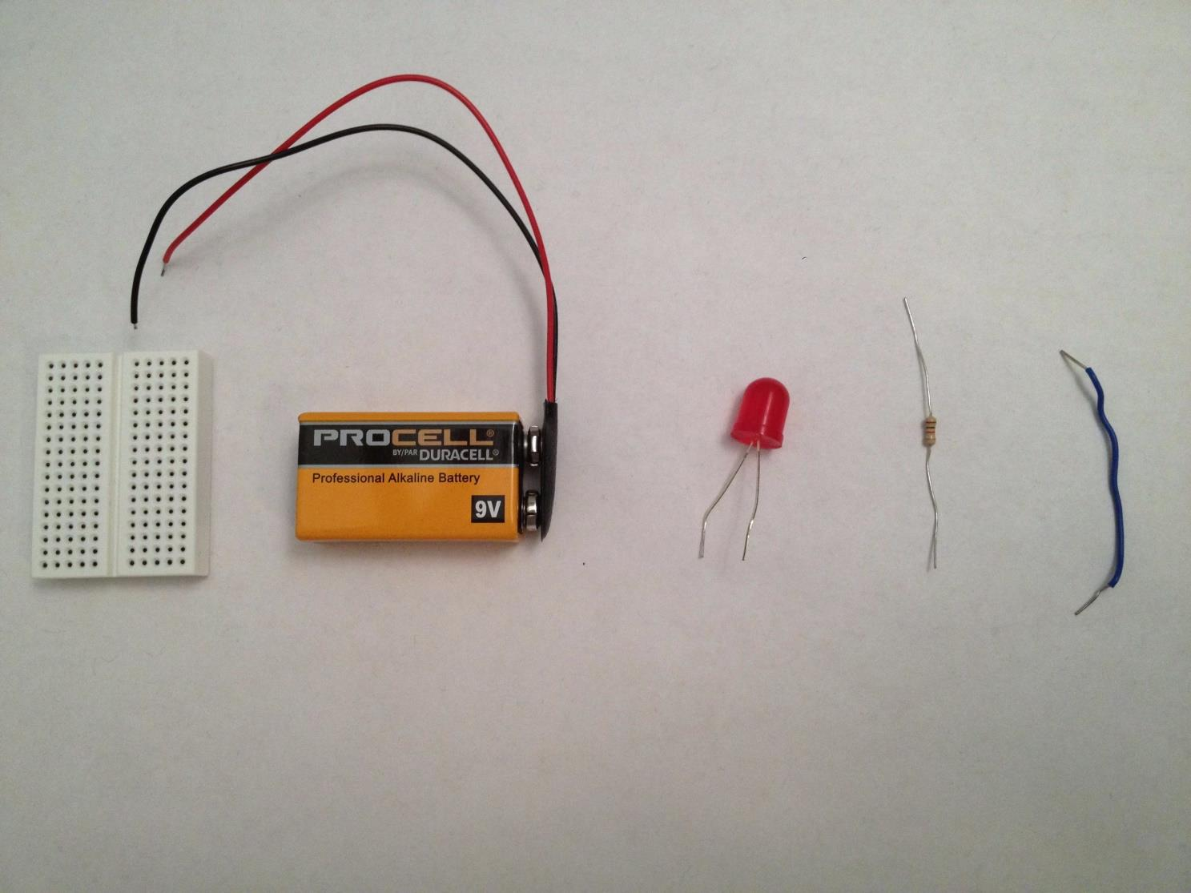

Make sure that when you put the LED in the breadboard, you put the LED’s longer lead in the same row as the red lead of the battery snap! Otherwise, nothing will happen!

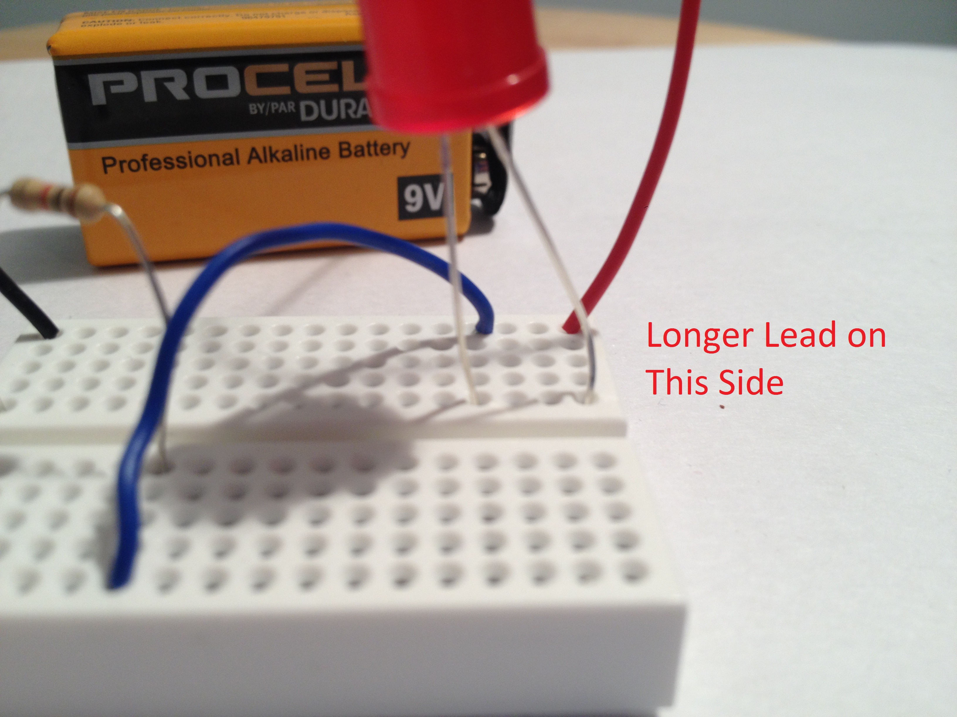

Once you complete the circuit, the LED should light up!

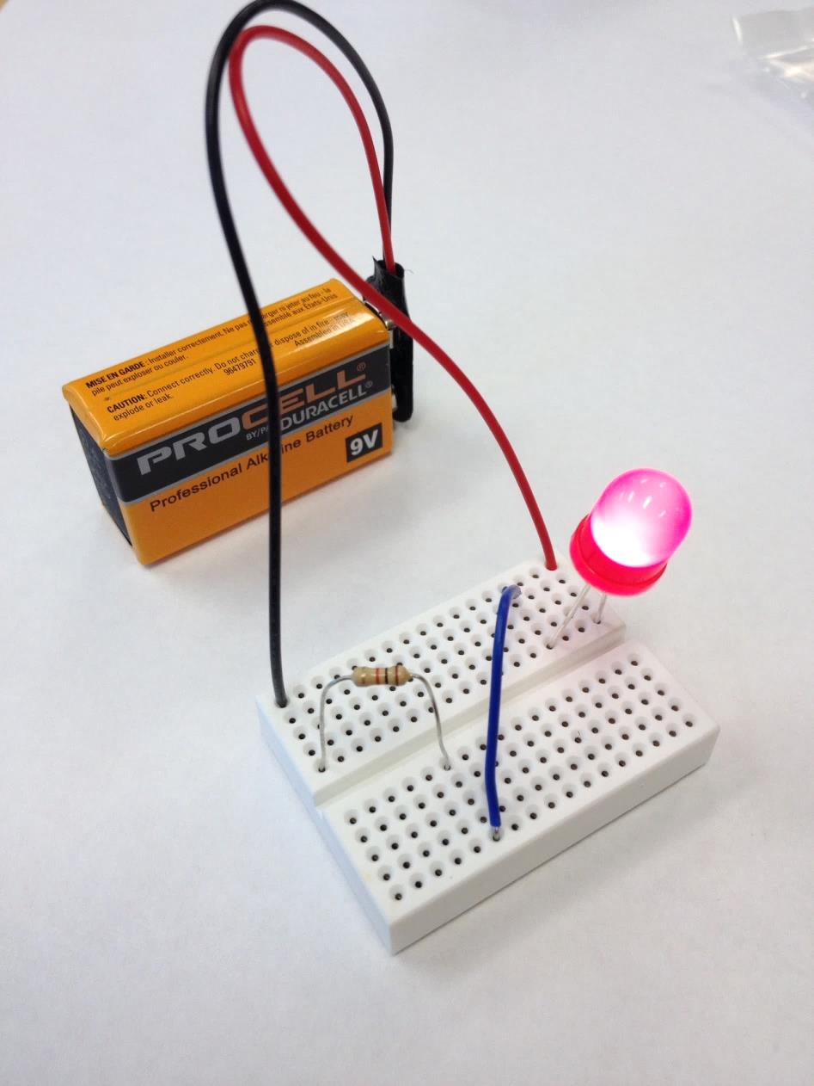

Basic LED Dimmer Circuit:

In order to make this circuit, you will need the following components:

1. Breadboard
2. Battery and Battery Snap
3. 2 LEDS
4. 2, 1k Resistors
5. Potentiometer
6. Jumper Wire

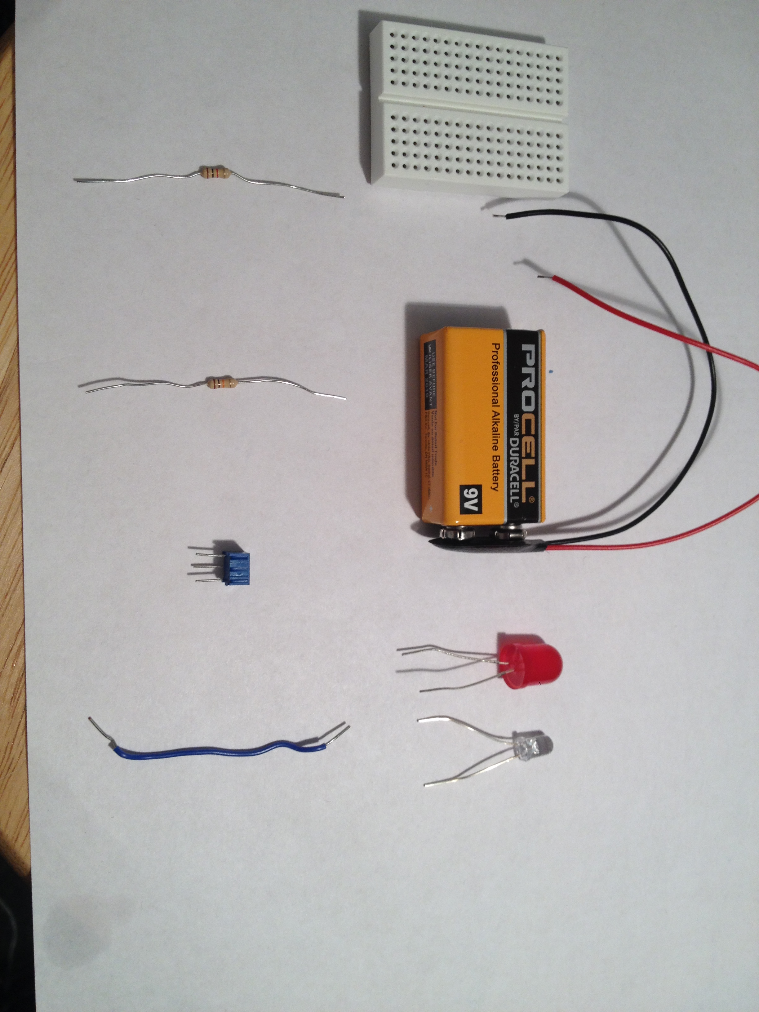

Remember that the longer lead of the LED needs to be in the same row as the red lead of the batter snap.

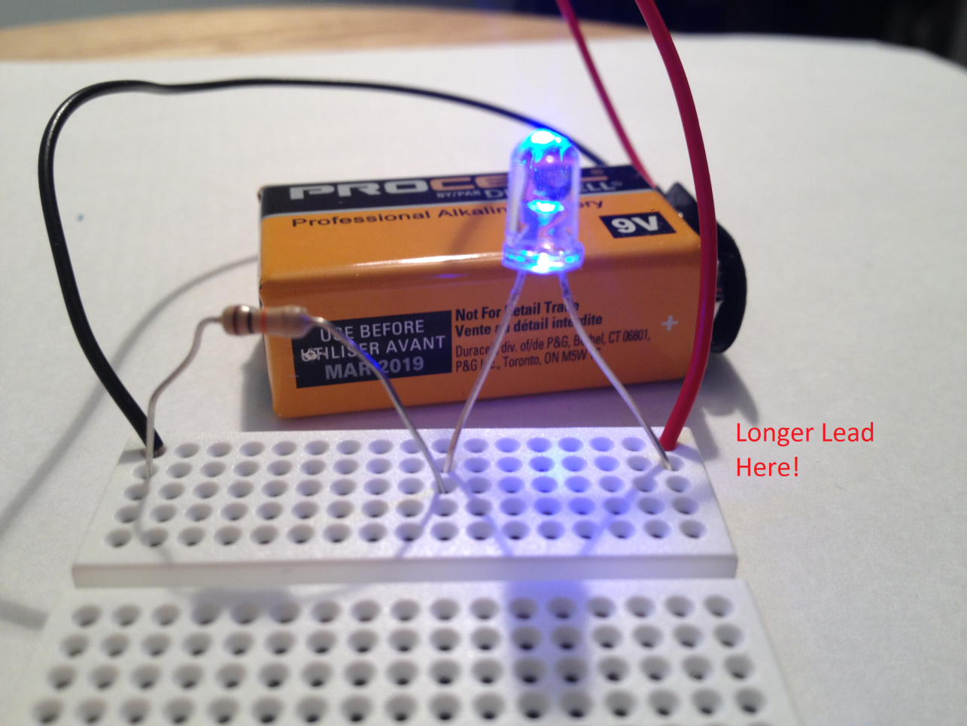

Make sure that the third lead of the potentiometer is NOT used. You can make sure of this by placing it at the end of the breadboard, such that its third lead hangs off of the side of the board.

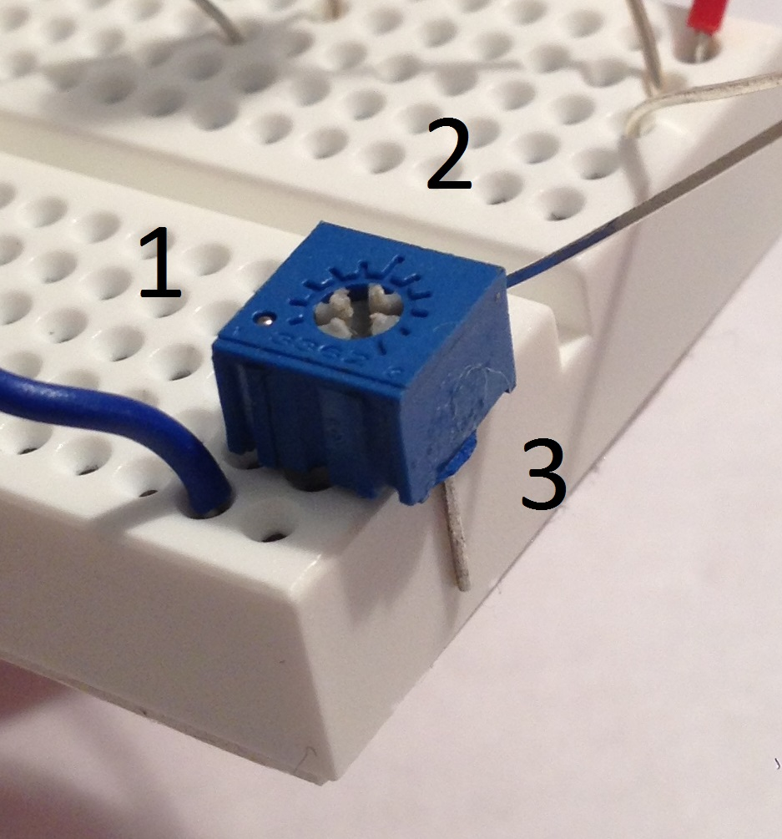

Make sure that lead 1 of the potentiometer is ONLY connected to the wire, while lead 2 of the potentiometer is ONLY connected to the shorter lead of the LED. The leads of the potentiometer should NOT be in the same row.

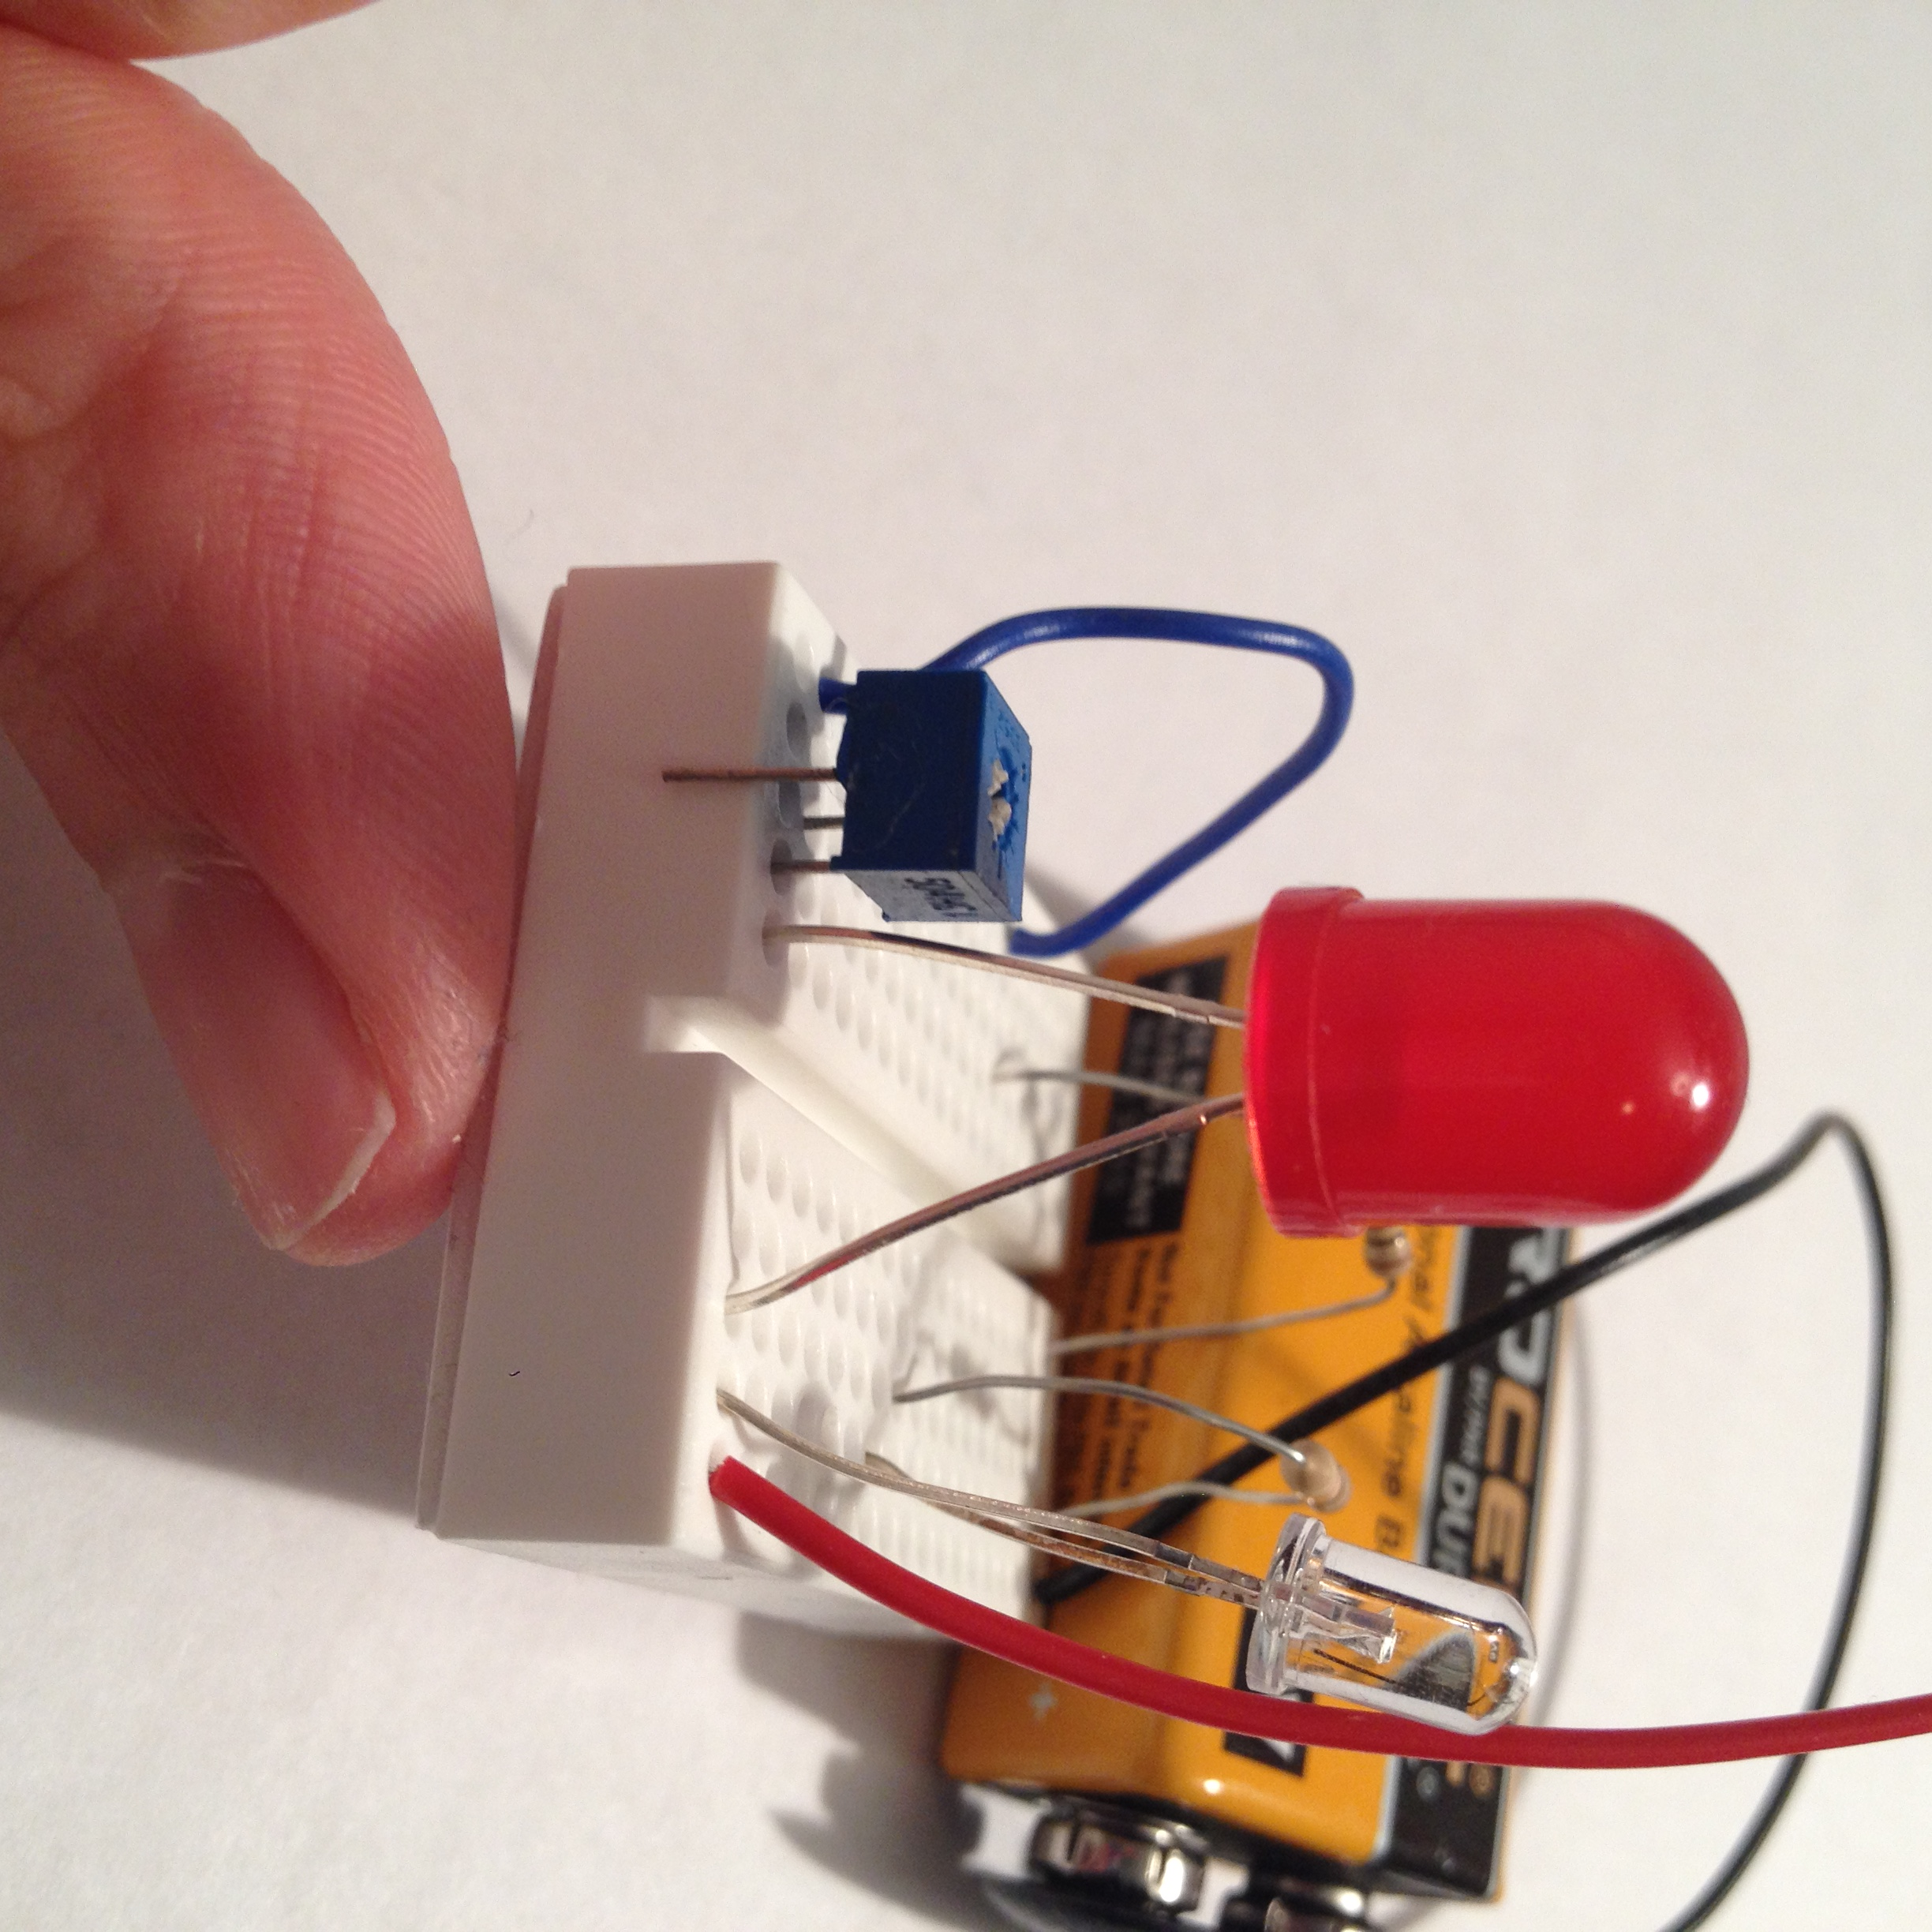

Below is the completed circuit. One of the LEDs should always be on, while the other one should either dim or brighten when the grey screw in the potentiometer is turned.

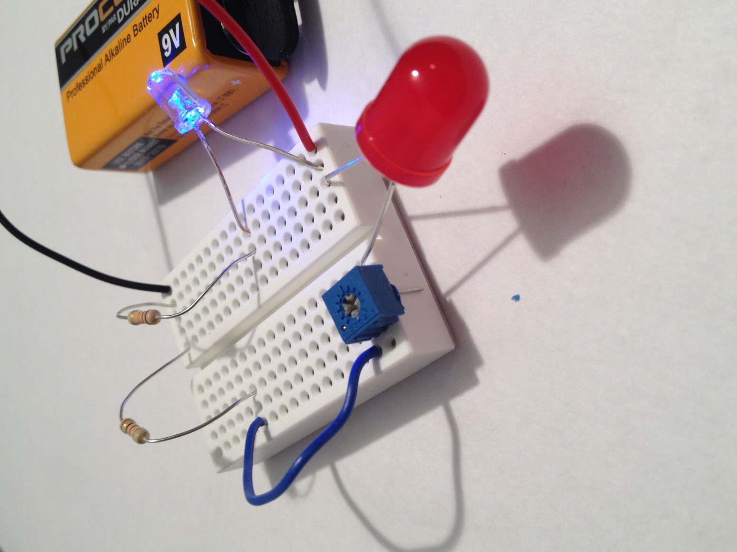

Welcome to the Resistance Circuit:

In order for you to join the resistance, you will need the following components:

1. Breadboard
2. Battery and Battery Snap
3. 2 LEDs
4. 3 Resistors:

* 1 1k Resistor (brown, black, red, gold)
* 2 10k Resistors (brown, black, orange, gold)

1. 1 10u Electrolytic Capacitor
2. 2 Transistors
3. A bunch of Jumper Wires

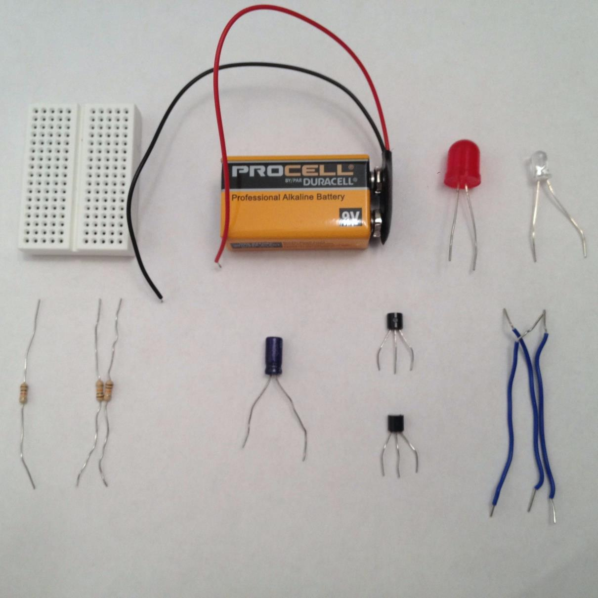

Make sure that the longer leads of both of the LEDs are connected to the same row as the red lead of the battery snap.

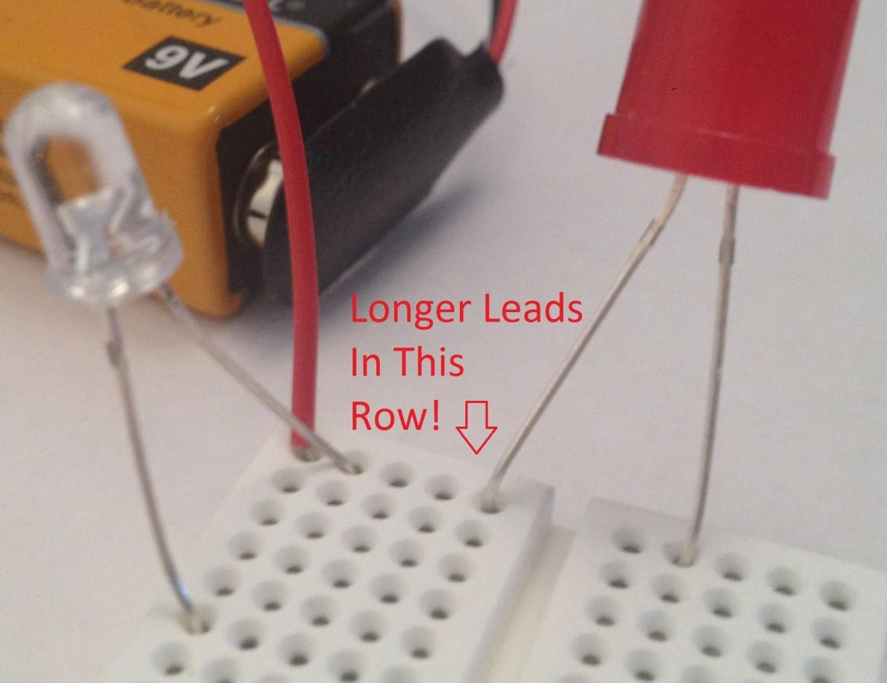

Next, install the transistors and **make note of their orientation**! **This is extremely important!!!**

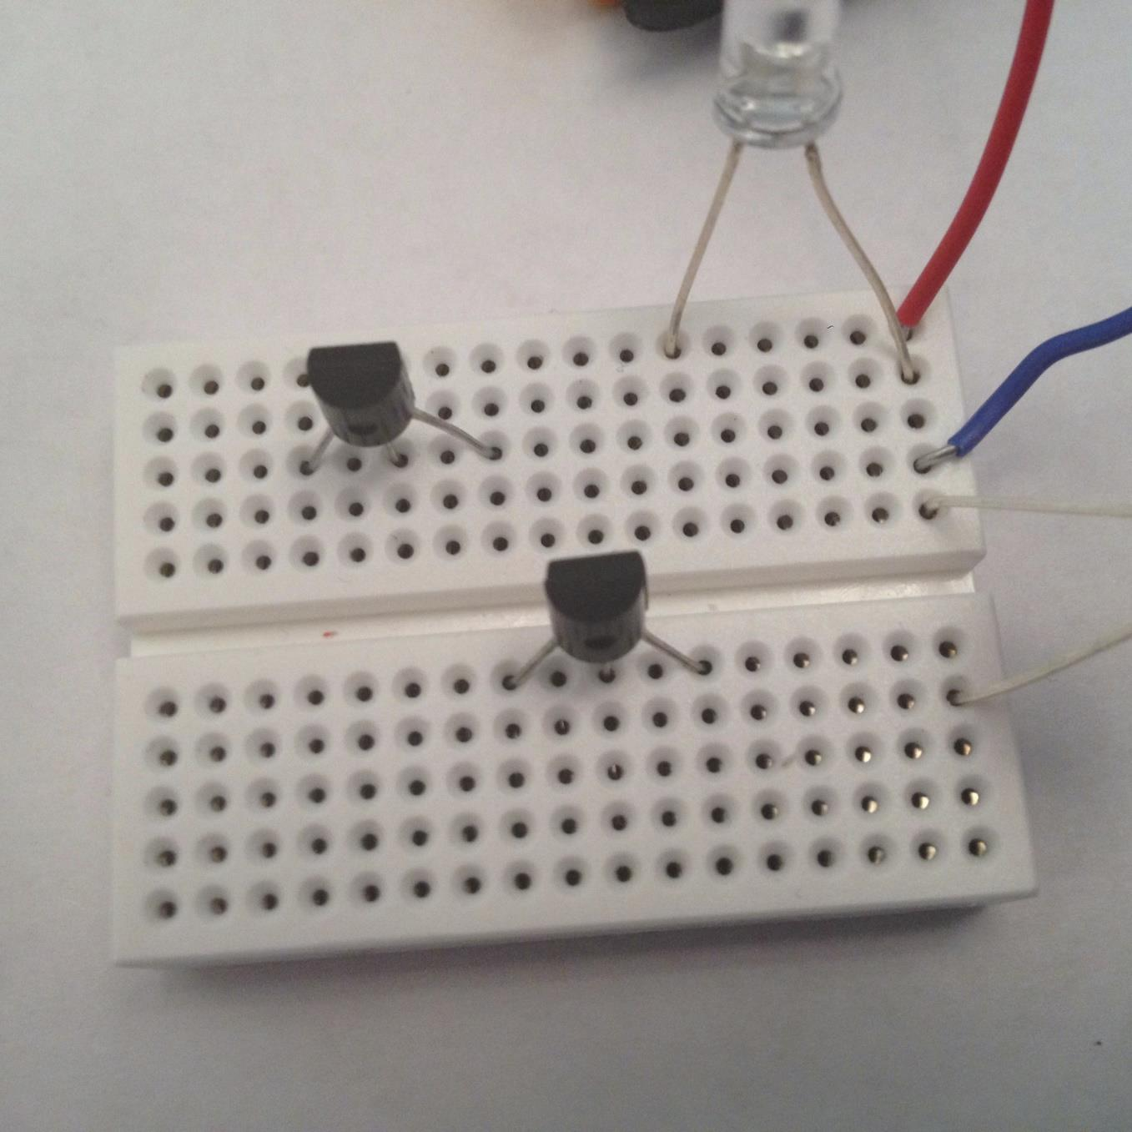

Install the resistors making note of which type of resistor goes where!

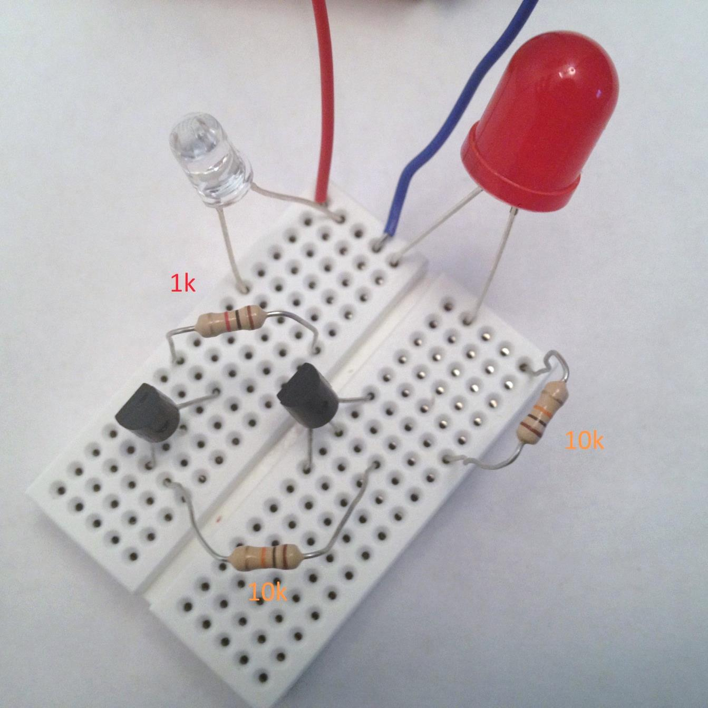

Install the capacitor making sure its longer lead is connected to the emitter of the transistor!

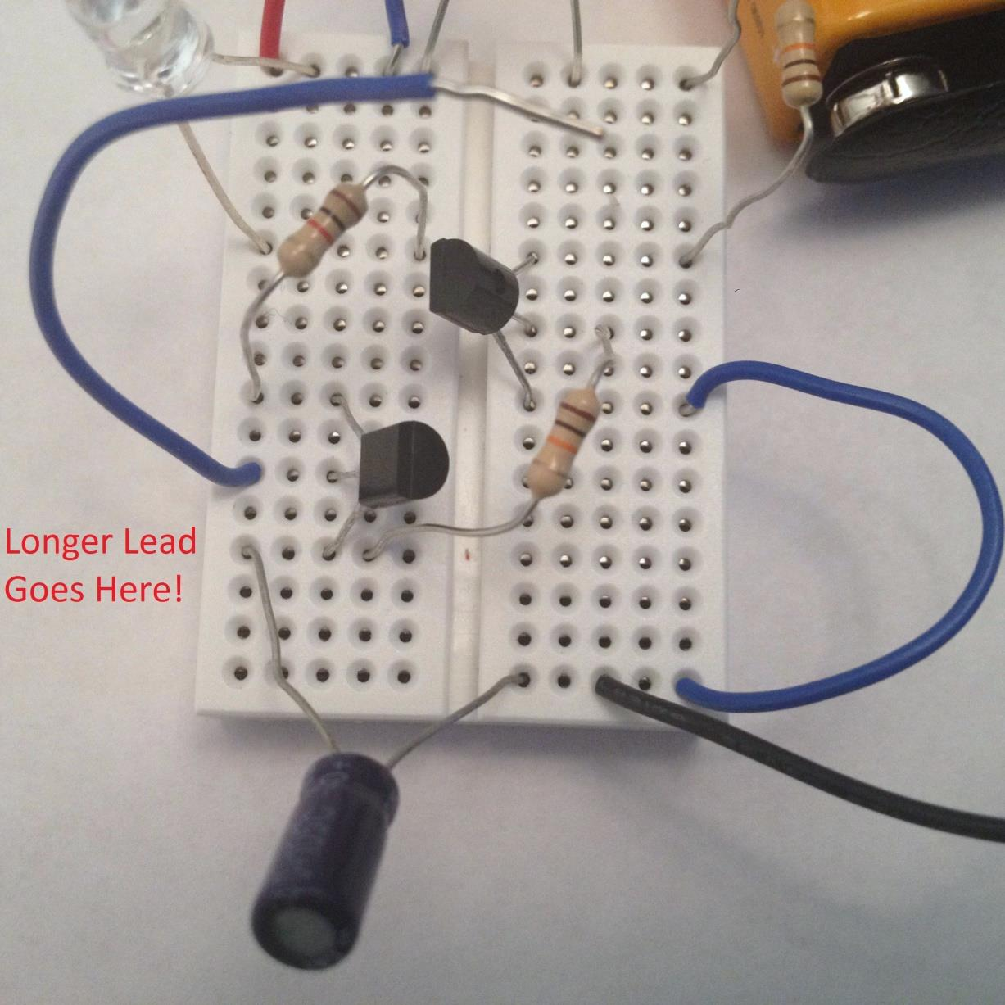

This is what the final circuit should look like. When you touch the ends of the two wires, both of the LEDs should light up. When you let go, one of the LEDs should turn off right away, while the other one should stay lit for a short period of time and then slowly dim until it no longer emits light.

